**Assignment 4**

**Group 3**

Yijie Wu, CID: 01894265

Qian Zhang, CID: 01939418

Dennis Wen, CID: 01973771

**2. A Leveraged Firm**

1. Let $r_{E}$ represents the rate of return of the equity holders.

Then, we have

$$r_{A}=wr_{B}+(1-w)r_{E}$$

Therefore,

$$r_{E}=\frac{r_{A}-wr_{B}}{1-w}$$

1. Let $β_{E}$ represents the beta of the return of the equity holders.

Then, we have

$$β_{E}=\frac{Cov(r_{E}, r_{M})}{σ_{M}^{2}}$$

Because $$r_{E}=\frac{r_{A}-wr_{B}}{1-w}$$

Therefore, we have

$$β_{E}=\frac{Cov(\frac{r_{A}-wr_{B}}{1-w}, r_{M})}{σ_{M}^{2}}=\frac{\frac{1}{1-w}[Cov\left(r_{A}, r_{M}\right)-Cov\left(wr_{B}, r_{M}\right)]}{σ_{M}^{2}}$$

Since $Cov\left(wr_{B}, r_{M}\right)=0$, we have

$$β_{E}=\frac{\frac{1}{1-w}[Cov\left(r_{A}, r_{M}\right)]}{σ_{M}^{2}}=\frac{β_{A}}{1-w}$$

1. Based on CAPM, we have

$$E\left[r_{E}\right]=r_{B}+β_{E}(E[r_{M}]-r_{B})$$

Since we know

$$β_{E}=\frac{β_{A}}{1-w}$$

Therefore, we have

$$E\left[r_{E}\right]=r_{B}+\frac{β_{A}}{1-w}({E[r}_{M}]-r_{B})$$

Because $β_{A}$ is positive and $E[r_{M}]-r_{B}>0$, we know that:

As $w$ increases, $E\left[r_{E}\right]$ increases.

If $w$ is close to 1, then $E\left[r_{E}\right]$ will be close to $∞$.

**3. Rough and Ready Calculations**

To answer this question, we use the idea of the annuity formula to discount all the future cashflow and calculate the PV of all future cashflow.

The table below is the binomial model of gold:

Given a gold price, the cashflow will be price – extraction cost. When the cashflow is negative, the gold will not be extracted from the Simplico gold mine and the cashflow is 0. Therefore, the binomial model of cashflow is:

In each time period but the $t_{0}$, there is more than one possible gold price. Therefore, we need to calculate the expected cash flow of each time period. The binomial model of the possibility of each gold price is:

With the table above, we could then calculate the expected value of cashflow at each time period:



And we could discount the expected value of cashflow by the risk-free rate $R$



Summing than together, the PV of all future cashflow is 3506.77. Multiplying the PV by 10K, the max extraction rate of each time period, the price of lease is 35067782.39 or 35.1M, which is larger than 24.1M. However, it can still prove that 24.1M is a reasonable value of the lease.

**4. Evaluating a More Complex Option on the Simplico Gold Mine**

Based on known parameters, we can calculate the risk-neutral probability:

$$q=\frac{R-d}{u-d}=\frac{1.1-0.9}{1.2-0.9}=\frac{2}{3}$$

$$1-q=\frac{1}{3}$$

Therefore, we can obtain the gold price according to binomial model:

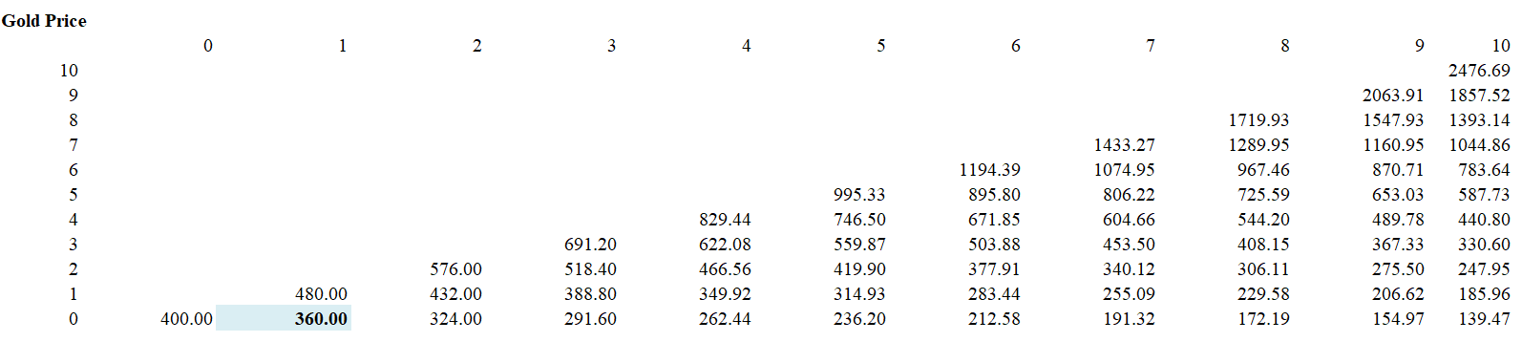

Then, we can calculate the lease price before introducing the new equipment:

$$V_{t}(s)=\frac{10k*\max\left\{0,s-200\right\}+[\frac{2}{3}V_{t+1}\left(us\right)+\frac{1}{3}V_{t+1}\left(ds\right)]}{1.1}$$

And we get the binomial tree of lease value with $V_{10}=0$:

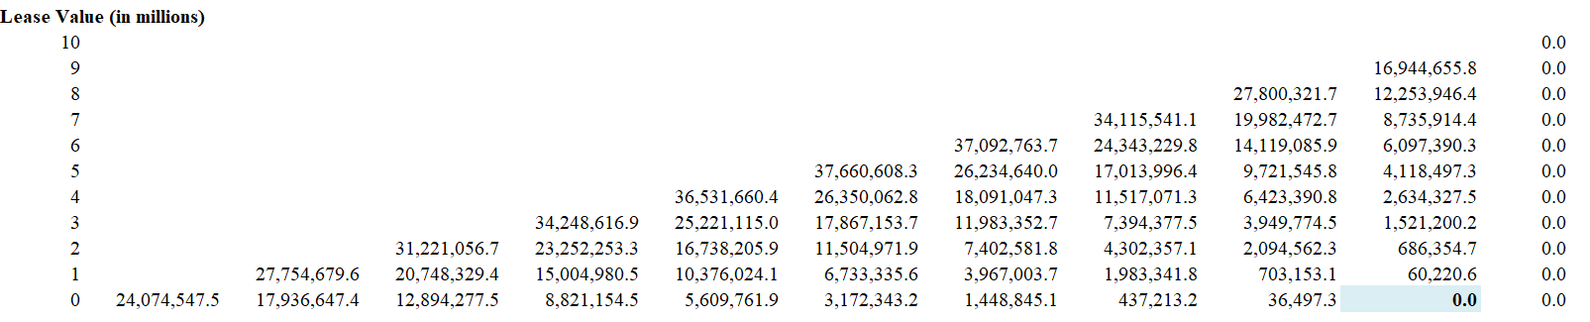

Because we can only add new equipment from the beginning at year 5, with $V_{10}=0$, we have:

From year 5 to year 9:

$$U_{t}\left(s\right)=\max\left\{\frac{14k*\max\left\{0,s-240\right\}+\left[\frac{2}{3}V_{t+1}\left(us\right)+\frac{1}{3}V_{t+1}\left(ds\right)\right]}{1.1}-5million, \frac{10k*\max\left\{0,s-200\right\}+\left[\frac{2}{3}U_{t+1}\left(us\right)+\frac{1}{3}U_{t+1}\left(ds\right)\right]}{1.1} \right\}$$

$$(t=5, 6, …, 9)$$

From year 0 to year 4:

$$V_{t}\left(s\right)=\frac{10k*\max\left\{0,s-200\right\}+\left[\frac{2}{3}V_{t+1}\left(us\right)+\frac{1}{3}V_{t+1}\left(ds\right)\right]}{1.1}, (t=0, 1, …, 4)$$

And we get the binomial tree of lease value if we can add new equipment:

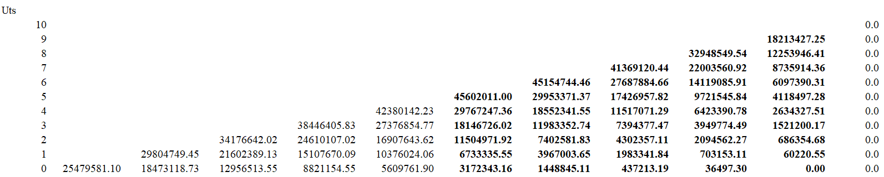

We can see that t=8 is the optimal timing to add new equipment with the new lease value of 28587189.6.

And when t=9, it is an optimal timing to add new equipment if we haven’t added any equipment yet. But we will add the equipment at t=8, so this is not the optimal timing.